**Name: ___________________________________ Date: __________________ Per: _______**

**Math 8 – Transformations and Similarity Test Review**

***Multiple Choice***

Identify the choice that best completes the statement or answers the question.

**_____1.** Write a description of the rule .

**(a)** translation 8 units to the right and 3 units up

**(b)** translation 8 units to the left and 3 units down

**(c)** translation 8 units to the right and 3 units down

**(d)** translation 8 units to the left and 3 units up

**For questions 2-3, use the graph below.**

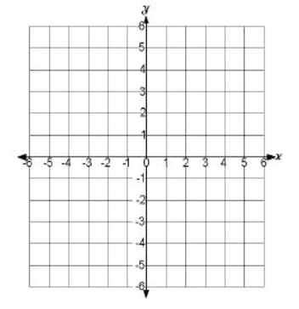

**2.** Point *A* (3, -5) is reflected over the *x*-axis. Plot point A on the graph, then plot and label A’.

**A’( , )**

**3.** Point *D* (-4, -1) is rotated 90° clockwise about the origin. Plot point D on the graph, then plot and label D*’.*

**D’( , )**

**4.** Which of the following transformations results in a similar figure? **Select all that apply.**

**(a)** dilation **(b)** rotation **(c)** reflection **(d)** translation



**5.** Write the coordinates for the

vertices of after  has been translated three units to the right and four units down?

**H’( , )**

**K’( , )**

**L’( , )**



**6.** If the given triangle was reflected over the y-axis to formwhat would be the coordinates of vertex Y’?

**Y’( , )**

**7.** Using the graph below, what is the rule for a translation from point *B* to point *F*?

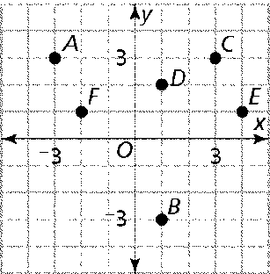

**Rule: (x , y ) 🡪 ( , )**

**8.**  was dilated by a scale factor of 6. The endpoints of the image are  and . What are the coordinates of the endpoints of the original line segment?

**F (______,________) G(_______,_______)**



**9.** Point *X* (-3, 4) is translated using the rule , then reflected over the *x*-axis.What is the coordinate of *X”*?

**X” (________,_________)**

_____10. A figure is located entirely in the fourth quadrant. If it is reflected over the x-axis, in which quadrant will its image lie?

a. first b. second c. third d. fourth

_____11. Which of the following transformations has the same result as a rotation of 90**°** counterclockwise?

a. dilation of scale factor of 3

b. rotation of 270**°** clockwise

c. reflection over the x-axis

d. translation down and to the right



**12.** **∆ABC is given with coordinates**

**A(-5, 1), B(-3, 6), and C(-2, 3).**

Draw an image rotated 270o counterclockwise about the origin. Label this image ∆A’B’C’. Find the coordinates of ∆A’B’C’.

**A’( , )**

**B’( , )**

**C’( , )**

***13.*** Using Point A’ from the previous problem, translate Point A’ left four units and down three units. Find the coordinates of A’’.

**A’’( , )**

14. Plot quadrilateral *ABCD* on the grid below with coordinates

A(4, 0), B(8, 4), C(8, 0) and D(4,4).



On the graph, draw the image of quadrilateral *ABCD* after a dilation of a scale factor of 1/4 about the origin. Label the image *A’B’C’D’*.

List the coordinates of the points.

**A’( , ) B’( , )**

**C’( , ) D’( , )**

15. ∆*ABC* has vertices *A* (1, -3), *B* (-2, 6), and *C* (-4, 3). It is dilated by a scale factor of 7. What are the coordinates of Point C’?

**C’ ( , )**

16. Triangle ABC ~ Triangle DEF. Find the value of x.

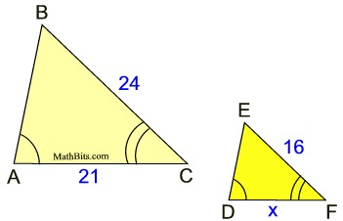

17. The rectangles below are similar. Find the scale factor between the two rectangles.

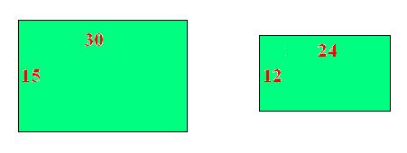

18. A man 6 feet tall casts a shadow that is 11 feet long. A building casts a shadow that is 385 feet long. How tall is the building? (Hint: Draw a picture)

19. Find the value of x.

x

10

8

4